
ST. MARY’S COLLEGE

CANTEEN PRICE LIST
Term 2 – 2025
Lunch orders to be in before recess.
Sandwiches to be given for late lunch orders or forgotten lunches.



SANDWICHES & ROLLS
(White, Wholemeal or Multigrain)
Sandwich Roll
Vegemite $2.50 $3.00
Cheese $3.50 $4.00
Cheese & Vegemite $4.00 $4.50
Cheese & Tomato $4.00 $4.50
Egg & Lettuce $4.50 $5.00
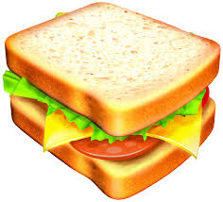
Ham $4.50 $5.00
Ham, Cheese $5.00 $5.50
Ham & Salad $5.50 $6.00
Chicken $4.50 $5.00
Chicken & Salad $5.50 $6.00
Tuna & Salad $6.50 $7.00
Cheese & Bacon Roll $3.00
TOASTED SANDWICHES EXTRA .50c
Extras: Carrot, Beetroot,
Cucumber & Onion: .50c ea
Avocado (in season): $1.00

HOT WRAPS
- Chicken Strips & Salad (*) $6.50
(*) = Tomato, lettuce served with
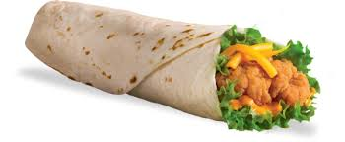
Sweet Chilli Sauce or Mayo
(Cheese extra .50c)
GLUTEN FREE
Lasagne $6.00
Spaghetti (small) $5.50
Lunch Bags .10c

Pizza: Ham & Pineapple/ $5.00
BBQ Chicken $5.00
Berry Muffins $3.50

MONDAY - Chicken Pasta Bake

TUESDAY - Mac ‘n’ Cheese
WEDNESDAY - Fried Rice
THURSDAY - Curried Sausage & Rice

Small $4.50 Medium $6.50

FRIDAY - Bacon Risotto $4.50
Nachos $4.50

HOT FOOD
Spaghetti Bolognese $4.50 sm $ 6.50 med
(with cheese extra .50c)
Meat Lasagne $5.00
Hot Chicken & Cheese Roll
& Mayo $6.50
Hot Chicken Roll & Mayo $6.00
Hot Chicken & Gravy Roll $6.50
Hot Chicken Strips & Gravy Roll $6.50
English Muffin Pizza: $4.00
- (Ham, Pineapple, Capsicum & Cheese, Tom Paste)
- BBQ (Chicken, Pineapple, Capsicum, Cheese)
Steamed Dim Sims $1.50

DRINKS
Water $2.50
100% Juice. Orange, Apple,
Apple/Blackcurrant $2.50

Breaka /Oak 600ml $4.00
(Choc, Coffee, Straw)
Oak 300ml $2.50
(Chocolate, Coffee, Strawberry)

COUNTER SALES
Toasted Banana Bread $2.00
Banana Muffin $2.00
Raspberry Muffin $2.00
Yoghurt $2.00
Popcorn – Plain $1.00
Ice Cream
Frosty Fruit $2.50
Gelati Cup (assorted flavours) $3.00
Frozen Juice Tubes $1.00
Apple Slinky $1.50
Own Apple slinked .20c

